******LEELA JANKI PUBLIC SCHOOL**

**Raghunathpuram, Petarwar, Bokaro**

**Transport Facility**

**Also Available**

**Chas, Bokaro to Petarwar**

**(Affiliated to CBSE New Delhi upto Senior Secondary Level)**

**Affiliation No-3430298, School No.66492**



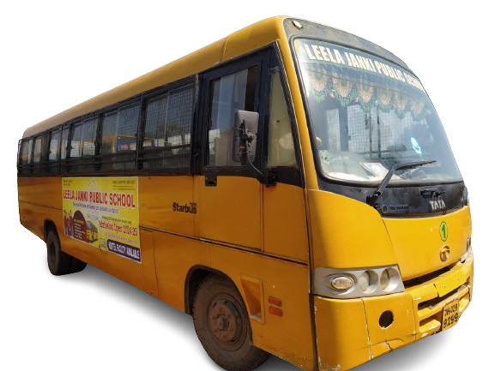



**NURSERY to IX & XI (Science, Commerce & Arts)**

**HOSTEL FACILITY AVAILABLE**

**Mobile No-8235011857, 9835323257**

**Website-www.leelajankipublicschool.com Email-contact@leelajankipublicschool.com**